|  |
| --- |
| # Write a function 'kalman_filter' that implements a multi-  # dimensional Kalman Filter for the example given  from math import *  class matrix:    # implements basic operations of a matrix class    def __init__(self, value):  self.value = value  self.dimx = len(value)  self.dimy = len(value[0])  if value == [[]]:  self.dimx = 0    def zero(self, dimx, dimy):  # check if valid dimensions  if dimx < 1 or dimy < 1:  raise ValueError, "Invalid size of matrix"  else:  self.dimx = dimx  self.dimy = dimy  self.value = [[0 for row in range(dimy)] for col in range(dimx)]    def identity(self, dim):  # check if valid dimension  if dim < 1:  raise ValueError, "Invalid size of matrix"  else:  self.dimx = dim  self.dimy = dim  self.value = [[0 for row in range(dim)] for col in range(dim)]  for i in range(dim):  self.value[i][i] = 1    def show(self):  for i in range(self.dimx):  print(self.value[i])  print(' ')    def __add__(self, other):  # check if correct dimensions  if self.dimx != other.dimx or self.dimy != other.dimy:  raise ValueError, "Matrices must be of equal dimensions to add"  else:  # add if correct dimensions  res = matrix([[]])  res.zero(self.dimx, self.dimy)  for i in range(self.dimx):  for j in range(self.dimy):  res.value[i][j] = self.value[i][j] + other.value[i][j]  return res    def __sub__(self, other):  # check if correct dimensions  if self.dimx != other.dimx or self.dimy != other.dimy:  raise ValueError, "Matrices must be of equal dimensions to subtract"  else:  # subtract if correct dimensions  res = matrix([[]])  res.zero(self.dimx, self.dimy)  for i in range(self.dimx):  for j in range(self.dimy):  res.value[i][j] = self.value[i][j] - other.value[i][j]  return res    def __mul__(self, other):  # check if correct dimensions  if self.dimy != other.dimx:  raise ValueError, "Matrices must be m*n and n*p to multiply"  else:  # multiply if correct dimensions  res = matrix([[]])  res.zero(self.dimx, other.dimy)  for i in range(self.dimx):  for j in range(other.dimy):  for k in range(self.dimy):  res.value[i][j] += self.value[i][k] * other.value[k][j]  return res    def transpose(self):  # compute transpose  res = matrix([[]])  res.zero(self.dimy, self.dimx)  for i in range(self.dimx):  for j in range(self.dimy):  res.value[j][i] = self.value[i][j]  return res    # Thanks to Ernesto P. Adorio for use of Cholesky and CholeskyInverse functions    def Cholesky(self, ztol=1.0e-5):  # Computes the upper triangular Cholesky factorization of  # a positive definite matrix.  res = matrix([[]])  res.zero(self.dimx, self.dimx)    for i in range(self.dimx):  S = sum([(res.value[k][i])**2 for k in range(i)])  d = self.value[i][i] - S  if abs(d) < ztol:  res.value[i][i] = 0.0  else:  if d < 0.0:  raise ValueError, "Matrix not positive-definite"  res.value[i][i] = sqrt(d)  for j in range(i+1, self.dimx):  S = sum([res.value[k][i] * res.value[k][j] for k in range(self.dimx)])  if abs(S) < ztol:  S = 0.0  try:  res.value[i][j] = (self.value[i][j] - S)/res.value[i][i]  except:  raise ValueError, "Zero diagonal"  return res    def CholeskyInverse(self):  # Computes inverse of matrix given its Cholesky upper Triangular  # decomposition of matrix.  res = matrix([[]])  res.zero(self.dimx, self.dimx)    # Backward step for inverse.  for j in reversed(range(self.dimx)):  tjj = self.value[j][j]  S = sum([self.value[j][k]*res.value[j][k] for k in range(j+1, self.dimx)])  res.value[j][j] = 1.0/tjj**2 - S/tjj  for i in reversed(range(j)):  res.value[j][i] = res.value[i][j] = -sum([self.value[i][k]*res.value[k][j] for k in range(i+1, self.dimx)])/self.value[i][i]  return res    def inverse(self):  aux = self.Cholesky()  res = aux.CholeskyInverse()  return res    def __repr__(self):  return repr(self.value)  ########################################  # Implement the filter function below  def kalman_filter(x, P):  for n in range(len(measurements)):    # measurement update  # prediction    return x,P  ############################################  ### use the code below to test your filter!  ############################################  measurements = [1, 2, 3]  x = matrix([[0.], [0.]]) # initial state (location and velocity)  P = matrix([[1000., 0.], [0., 1000.]]) # initial uncertainty  u = matrix([[0.], [0.]]) # external motion  F = matrix([[1., 1.], [0, 1.]]) # next state function  H = matrix([[1., 0.]]) # measurement function  R = matrix([[1.]]) # measurement uncertainty  I = matrix([[1., 0.], [0., 1.]]) # identity matrix  print(kalman_filter(x, P))  # output should be:  # x: [[3.9996664447958645], [0.9999998335552873]]  # P: [[2.3318904241194827, 0.9991676099921091], [0.9991676099921067, 0.49950058263974184]] |

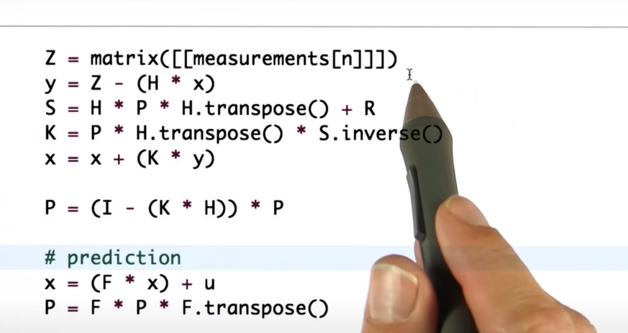

|  |
| --- |
| # Fill in the matrices P, F, H, R and I at the bottom  #  # This question requires NO CODING, just fill in the  # matrices where indicated. Please do not delete or modify  # any provided code OR comments. Good luck!  from math import *  class matrix:    # implements basic operations of a matrix class    def __init__(self, value):  self.value = value  self.dimx = len(value)  self.dimy = len(value[0])  if value == [[]]:  self.dimx = 0    def zero(self, dimx, dimy):  # check if valid dimensions  if dimx < 1 or dimy < 1:  raise ValueError, "Invalid size of matrix"  else:  self.dimx = dimx  self.dimy = dimy  self.value = [[0 for row in range(dimy)] for col in range(dimx)]    def identity(self, dim):  # check if valid dimension  if dim < 1:  raise ValueError, "Invalid size of matrix"  else:  self.dimx = dim  self.dimy = dim  self.value = [[0 for row in range(dim)] for col in range(dim)]  for i in range(dim):  self.value[i][i] = 1    def show(self):  for i in range(self.dimx):  print self.value[i]  print ' '    def __add__(self, other):  # check if correct dimensions  if self.dimx != other.dimx or self.dimy != other.dimy:  raise ValueError, "Matrices must be of equal dimensions to add"  else:  # add if correct dimensions  res = matrix([[]])  res.zero(self.dimx, self.dimy)  for i in range(self.dimx):  for j in range(self.dimy):  res.value[i][j] = self.value[i][j] + other.value[i][j]  return res    def __sub__(self, other):  # check if correct dimensions  if self.dimx != other.dimx or self.dimy != other.dimy:  raise ValueError, "Matrices must be of equal dimensions to subtract"  else:  # subtract if correct dimensions  res = matrix([[]])  res.zero(self.dimx, self.dimy)  for i in range(self.dimx):  for j in range(self.dimy):  res.value[i][j] = self.value[i][j] - other.value[i][j]  return res    def __mul__(self, other):  # check if correct dimensions  if self.dimy != other.dimx:  raise ValueError, "Matrices must be m*n and n*p to multiply"  else:  # subtract if correct dimensions  res = matrix([[]])  res.zero(self.dimx, other.dimy)  for i in range(self.dimx):  for j in range(other.dimy):  for k in range(self.dimy):  res.value[i][j] += self.value[i][k] * other.value[k][j]  return res    def transpose(self):  # compute transpose  res = matrix([[]])  res.zero(self.dimy, self.dimx)  for i in range(self.dimx):  for j in range(self.dimy):  res.value[j][i] = self.value[i][j]  return res    # Thanks to Ernesto P. Adorio for use of Cholesky and CholeskyInverse functions    def Cholesky(self, ztol=1.0e-5):  # Computes the upper triangular Cholesky factorization of  # a positive definite matrix.  res = matrix([[]])  res.zero(self.dimx, self.dimx)    for i in range(self.dimx):  S = sum([(res.value[k][i])**2 for k in range(i)])  d = self.value[i][i] - S  if abs(d) < ztol:  res.value[i][i] = 0.0  else:  if d < 0.0:  raise ValueError, "Matrix not positive-definite"  res.value[i][i] = sqrt(d)  for j in range(i+1, self.dimx):  S = sum([res.value[k][i] * res.value[k][j] for k in range(self.dimx)])  if abs(S) < ztol:  S = 0.0  try:  res.value[i][j] = (self.value[i][j] - S)/res.value[i][i]  except:  raise ValueError, "Zero diagonal"  return res    def CholeskyInverse(self):  # Computes inverse of matrix given its Cholesky upper Triangular  # decomposition of matrix.  res = matrix([[]])  res.zero(self.dimx, self.dimx)    # Backward step for inverse.  for j in reversed(range(self.dimx)):  tjj = self.value[j][j]  S = sum([self.value[j][k]*res.value[j][k] for k in range(j+1, self.dimx)])  res.value[j][j] = 1.0/tjj**2 - S/tjj  for i in reversed(range(j)):  res.value[j][i] = res.value[i][j] = -sum([self.value[i][k]*res.value[k][j] for k in range(i+1, self.dimx)])/self.value[i][i]  return res    def inverse(self):  aux = self.Cholesky()  res = aux.CholeskyInverse()  return res    def __repr__(self):  return repr(self.value)  ########################################  def filter(x, P):  for n in range(len(measurements)):    # prediction  x = (F * x) + u  P = F * P * F.transpose()    # measurement update  Z = matrix([measurements[n]])  y = Z.transpose() - (H * x)  S = H * P * H.transpose() + R  K = P * H.transpose() * S.inverse()  x = x + (K * y)  P = (I - (K * H)) * P    print 'x= '  x.show()  print 'P= '  P.show()  ########################################  print "### 4-dimensional example ###"  measurements = [[5., 10.], [6., 8.], [7., 6.], [8., 4.], [9., 2.], [10., 0.]]  initial_xy = [4., 12.]  # measurements = [[1., 4.], [6., 0.], [11., -4.], [16., -8.]]  # initial_xy = [-4., 8.]  # measurements = [[1., 17.], [1., 15.], [1., 13.], [1., 11.]]  # initial_xy = [1., 19.]  dt = 0.1  x = matrix([[initial_xy[0]], [initial_xy[1]], [0.], [0.]]) # initial state (location and velocity)  u = matrix([[0.], [0.], [0.], [0.]]) # external motion  #### DO NOT MODIFY ANYTHING ABOVE HERE ####  #### fill this in, remember to use the matrix() function!: ####  P = # initial uncertainty: 0 for positions x and y, 1000 for the two velocities  F = # next state function: generalize the 2d version to 4d  H = # measurement function: reflect the fact that we observe x and y but not the two velocities  R = # measurement uncertainty: use 2x2 matrix with 0.1 as main diagonal  I = # 4d identity matrix  ###### DO NOT MODIFY ANYTHING HERE #######  filter(x, P) |

